TRANSLATIONAL RESEARCH AWARD

Scheme Information and Guidance for Applicants

Value of the grant:

The standard maximum value of our Translational Research Award is £250,000, but we may consider applications above this amount.

If your project requires more than £250,000, please get in touch with our grants team by emailing grants@sightresearchuk.org to discuss your requirements before applying. They can advise you as to whether you would be eligible for a larger grant under this funding

Applicants should note that projects must have clearly defined progression milestones and funding will be subject to the achievement of the relevant milestones.

Duration of the grant:

The standard maximum time period for grants under this Award is 24 months.

If your project requires more than 24 months, please email our grants team grants@sightresearchuk.org before applying to check if your application would be eligible for your requested duration.

Who can apply?

Researchers in Higher Education Institutions, NHS based clinicians and clinical researchers, and allied healthcare professionals.

We accept applications for projects that will be carried out across multiple UK institutions, but the funding will be awarded to the lead applicant’s host institution.

We accept applications for projects that will be carried out in collaboration with international research partners, but the funding will be awarded to the lead applicant’s UK host institution.

We encourage multidisciplinary applications in which the lead applicant and co-applicants/collaborators have different skill sets.

A lead applicant may only submit one application per round as lead applicant.

What does the scheme support?

The Translational Research Award supports research projects with a clearly defined pathway to delivering new and more effective solutions for patients in the UK. Its goal is to help to accelerate the translation of pre-clinical science to the development of new therapies, devices and diagnostics.

What are we looking for?

- Innovative and novel translational projects that address an unmet clinical need for people living with sight threatening conditions in the UK.
- Projects at Translational Readiness Levels 5, 6, or 7. Examples of projects which fall within these Translational Readiness Levels include:
- First in man studies
- Drug repurposing studies
- Dose ranging studies
- Late stage laboratory validation of an asset or technology
- Validation of previously discovered biomarkers
- New methods of diagnosis
- Treatment and prevention in man
- Projects that are relevant to and highly promising in the clinical setting (i.e., the applicants have already shown that the idea might be used as therapy in man. We do not fund early stage / proof of concept studies).
- For clinical projects we strongly recommend ensuring significant experienced clinical input is involved in the project and application.
- Where the project is focussed on drug development, we welcome projects that assess properties such as potency, efficacy, selectivity, or bioavailability of compounds that are being prepared for first-in-man studies.
- Projects that have robust commercial potential, likely to attract follow-on large-scale funding from other charitable, statutory, or industry funders.
- Projects that are milestone-driven and have a realistic delivery plan.

Applications must:

- Provide supporting proof of concept data.
- Illustrate the advantages of the proposed solution over competing or existing solutions.
- Outline a clear set of not overlapping milestones, with Go/No-go decision points.
- Identify funding routes beyond the Sight Research UK Translational Award (e.g., MRC Development Pathway Funding Scheme; statutory translational funding; industry funding, etc.).

We welcome projects that have a strong intellectual property (IP) position and which have identified a potential route to market and commercialisation beyond the life of the grant.
The key requirements we see as constituting a strong IP position include:
- The applicant has the rights to all IP required for the conduct of the project.
- The applicant has a strategy to protect the IP of the project going forward.
- Where there is a collaborator, there is a plan to share and manage the outputs, including an indication of whether a lead exploiting party has been identified and agreed.

Applications can include:

- Pre-clinical testing of novel near-ready therapeutic entities (e.g., potential new drugs and devices).
- Repurposing clinical studies – using existing therapies for new indications in eye diseases or visual disorders.
- Developing and testing novel devices with a clear and defined patient benefit.
- Developing and testing diagnostics (including biomarker validation, but not discovery).
- All research should strengthen confidence that a target or therapeutic approach will be applicable to visual conditions.

Translational Readiness Levels (TRLs)
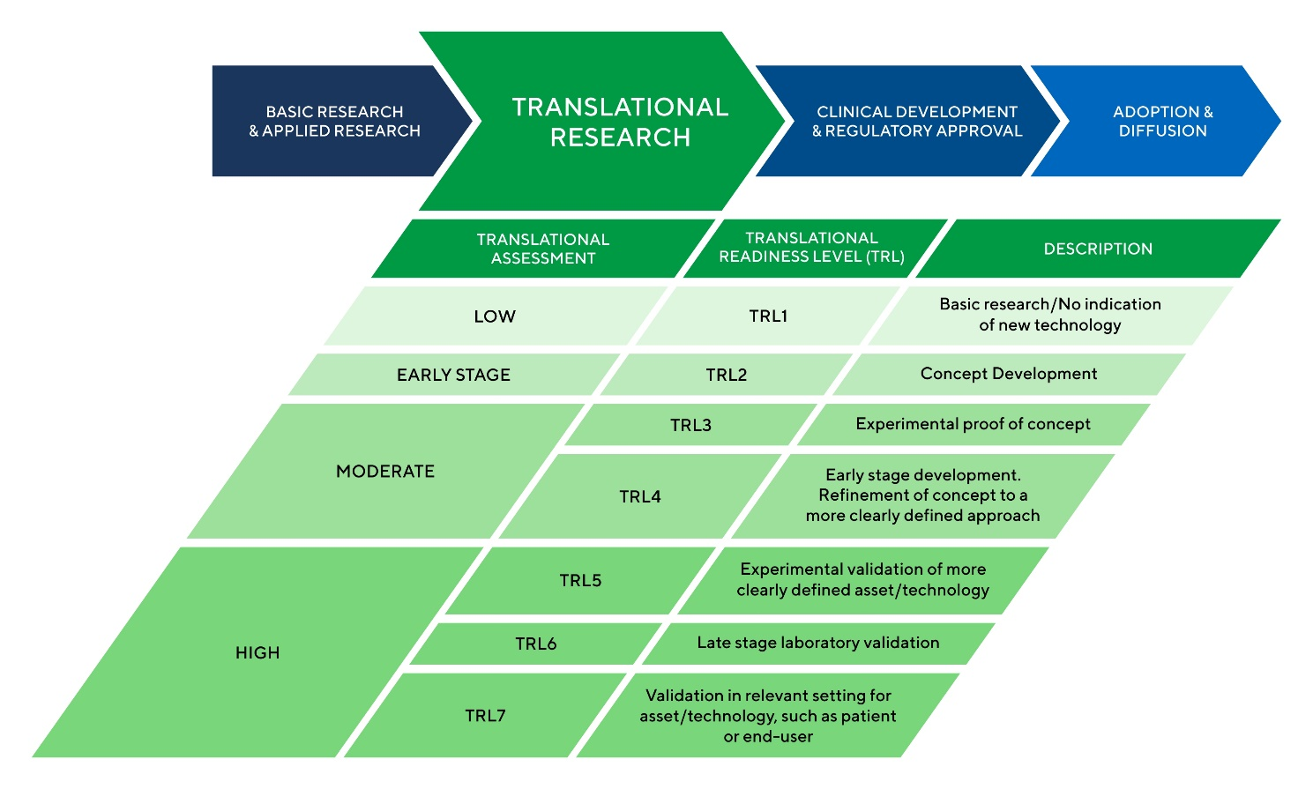

Please note that applications at an earlier translational stage than TRL 5 will not be considered under this funding scheme.
From past experience, some Stage 1 applications have implied a TRL of 5 or above , which was then not supported in the second more detailed application stage. We are mindful of the time required in writing applications and want to ensure that your resources are best utilised. As such, please be realistic in assessing the TRL of your project and clearly justify in your application why your project meets a minimum of TRL 5. The TRL of an application will be assessed by our Research Advisory Board and any project deemed to have a TRL lower than 5 will not be recommended for funding through this Award.
Below we have included some points from previous grant rounds to help you assess whether your project is at the correct TRL for this funding scheme.
- An application must clearly show pre-clinical proof of concept to be eligible. Applications without preliminary data available to support the concept will not be progressed.
- Innovations developed in non-ocular settings with no proof of concept for ocular application will not be progressed.
- Screening libraries for biological targets would be too exploratory for this grant call.
- Proposals must provide a clearly defined translation leading to patient benefit. Exploratory research, even in a patient setting, will not be considered.

For an example of a project that is at an appropriate TRL for this funding scheme, and has received funding in a previous grant round, please click here.
If you have any questions regarding the TRL of your application, please do get in touch by emailing grants@sightresearchuk.org.

What is covered by the grant?

The grant can be used flexibly to meet several types of expenditure:
- Salary contributions on this grant are typically envisaged for staff appointed with the sole purpose of working on the proposed project (such as Research Assistants or other postdoctoral, contract staff). Please note that the grant is not intended for PhD students.
- Salary costs can be allocated to more than one staff member (e.g. Research Assistant) who may be working part time on the proposed project and other concomitant projects in the same or another host institution. This may be the case for interdisciplinary projects.
- Please note that salary contributions are not to be used to supplement or replace salary funding for core staff provided by HEFCE or the NHS. Full salary cost justifications are required in your application. Please ask us if in doubt before submitting your application.
- Salary costs of core funded staff are only covered (pro rata) in the exceptional circumstances that their time needs to be "bought out" partially or in full from other duties such as teaching or clinical work to allow them to dedicate time to directly carry out the proposed project (i.e. directly carrying out laboratory work, conducting field work, etc.).
- Project consumables.
- Any other direct costs of the translational projects, such as a contribution towards equipment needed for the research project.
- The cost of outsourcing project work to contract research organisations which provide specific input on a fee-for-service basis. Appropriate justification should be provided in your application, and contractors will have no potential claim over any arising IP.

Applications for the following are not accepted:

- PhD studentships.
- Fundamental or basic research into the causes of visual disorders.
- Disease modelling research.
- Exploratory research (e.g. screening libraries for biological targets).
- Projects with no clear pathway to patient benefit.
- Projects without proof of concept preliminary data.
- Salaries of staff between posts/funding (i.e., as “bridging” funds).
- General consumables for a research group.
- General support for a research group.
- The development of non-therapeutic or non-diagnostic devices.
- Innovations developed in non-ocular settings with no proof of concept for ocular application.

Other indirect costs not covered by the scheme:

Any costs not directly incurred by the project (departmental costs, general university charges, apprenticeship levy, etc.) are not covered by the scheme.

- Indirect costs of research in universities can be covered by the Charity Research Support Fund.
- Indirect costs of clinical research in the NHS can be covered by NIHR Clinical Research Networks under the Attributing the costs of health and social care Research and Development agreement.

Use of animals in research:

As a member of the AMRC, Sight Research UK abides by their principles of best practice in the use of animals in research.
Applicants planning to use animals in their project will need to provide justification for their use, and for the numbers of animals used. Please note that an assessment of the 3Rs (reduction, refinement, and replacement of animals) forms part of our peer review process and that any project planning the use of non-human primates, cats, dogs or horses will be further assessed by NC3Rs as part of our review process.

How to apply:

All application forms are available on our website. Applications are submitted by email to grants@sightresearchuk.org by the deadlines specified at each grant round.

How we assess applications:

Applications are assessed in two stages:

- Stage 1: Applications are a brief expression of interest outlining the proposed project. These are assessed by relevant members of our independent Research Advisory Board depending on their expertise. Within five weeks of the Stage 1 deadline, applicants will be notified as to whether they have been short-listed to submit a Stage 2 application. Unsuccessful applicants are also notified, and feedback is provided wherever possible.

- Stage 2: Following notification of Stage 1 outcome, applicants have six weeks to submit their Stage 2 application along with a completed Project Milestones Plan.

- External peer review: Stage 2 applications are assessed by up to four external peer reviewers per application. These are relevant experts drawn from the fields of translational research, clinical research, clinical practice, and industry and are selected to match their expertise to the proposed project. We will do whatever possible to avoid bias either for or against the applicant and/or the host institution. We will also seek to protect confidentiality and not contact competing research groups either in the UK or overseas. Applicants are asked to suggest names of peer reviewers to approach and also those that we should not seek a review from. External peer reviewers have four weeks to return their reviews.

- Rebuttal: Applicants have the opportunity for rebuttal following receipt of external peer reviews. Any rebuttal must be received within 10 working days of request from the Sight Research UK Grants Team.

- Research Advisory Board meeting: All external peer reviews and applicants’ rebuttals are sent to the Research Advisory Board at least two weeks prior to their meeting. All Stage 2 applications are considered at the same Research Advisory Board meeting.

- Trustees Board meeting: The Chair of the Research Advisory Board, or nominated representative, reports the advice on funding recommendations from the Research Advisory Board to the Board of Trustees. The Trustees make their grant-making decisions based on the expert advice and on the financial capacity of the organisation at the time.

- Feedback: Following the Board of Trustees’ decision, the Grants Team provides feedback to all applicants, whether successful or unsuccessful. Wherever possible, we share the views of the Research Advisory Board and of the external peer reviewers who reviewed the applications. Grant Award contracts are issued to all successful candidates and the Grants Team liaises with the award holders throughout the life of the award.

Intellectual Property:

Grant holders will be asked to report on any intellectual property (IP) generated by their Sight Research UK funded research and describe the development and commercialisation plans of any results and any IP.

Reporting:

Grant holders are expected to report to Sight Research UK in accordance with the Terms and Conditions of the Translational Research Award. Reporting requirements will be outlined at the time of the award offer, but these typically include milestones-based reporting, some brief touchpoints to ensure that the project is running on schedule, and annual and final reports, depending on the duration of the award.

Grant holders are also required to continue to report on their post-award progress up to 5 years after the award has been completed (via Researchfish). This is mandatory to ensure evaluation of the translational impact of this scheme.

Confidentiality:

To protect the confidentiality of the information shared with us by the applicants, everyone involved in the review process of any Translational Award application is asked to abide by our Conflict of Interest policy.

Timelines

Translational Research award grant round timelines are available on our website.

Contact details

For all enquiries, please contact grants@sightresearchuk.org or call 0117 325 7757.

